** East West University**

**Course No: CSE109 Lab**

**Experiment Number:** 07

**Experiment Name:** Studying the Characteristics of R-C branch in an AC Circuit.

**Date of Experiment: 10/11/2016**

**Date of submission: 24/11/2016**

**Group: 5**

**ID: 2016-1-60-053**

**2016-1-60-057**

**2016-1-60-058**

**2016-1-60-060**

**Experiment Number:** 07

**Experiment Name:** Studying the Characteristics of R-C branch in an AC Circuit.

**Objectives:** The objectives of this experiment is to study the characteristics of R-C branch and measure the impendence of the branch.

**1. Equipment / Apparatus:**

(i) Function generator (01)

(ii) Oscilloscope (01)

(iii) Probe (02)

(iv) Resistor (100ohm)

(v) Capacitor (1µF)

(vi) Multi-meter (01)

(vii) Breadboard

(viii) Wires

**2. Experimental Setup:**

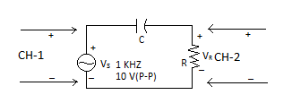

Fig. 1

**3. Procedure:**

(i) Measure the resistance of the resistor.

(ii) Connect the circuit as shown in **Fig. 1**.

(iii) Turn ON the function generator and oscilloscope.

(iv) Set the frequency ƒ of the function generator at 1KHz by rotating the frequency adjustment KNOB. Also press the sine function button.

(v) Connect **CH-1** and **CH-2** as shown in the figure.

(vi) Set the oscilloscope to the CH-1 only.

(vii) Adjust the TIME/DIV and VOLT/DIV KNOBs such that 2 to 3 cycles of sine wave is appeared in CH-1 clearly .

(viii)Set the AMPL KNOB of the function generator such that peak to peak voltage is found to be 10 V in the oscilloscope.

(ix) Measure the time period *T* from the oscilloscope.

(x) Set the oscilloscope to observe the CH-1 and CH-2 together. Set the VOLT/DIV KNOB of CH-2 such that both the waveforms are seen clearly. The waveform of which channel is leading and why ?

(xi) Set Measure the time delay *Tdelay* between the waveforms seen in the oscilloscope .

(xii) Measure the voltage Vs and VR across the function generator and the resistor by using the multi-meter in AC mode .

(xiii) Perform the calculations below.

**4. Data Table:**

|  |  |  |  |  |
| --- | --- | --- | --- | --- |
| *T*  (ms) | Which Channel Leads | *Tdelay*  (ms) | *Vs*  (V) | *VR*  (V) |
| 1 | 2 | 0.16 | 3.59 | 1.65 |

5**. Calculation:**

(i) Frequency, ƒ = *1/ T* = 1000 Hz

(ii) Phase difference, Ɵ = 360 ƒ *Tdelay* = 57.6°

(iii) Magnitude of impendence, |Z| = R* Vs / VR = 213.22

(iv) Theoretical phase difference, Ɵ = tan­-1 (1/(2πƒCR)) = 58.38°

(v) Theoretical magnitude of impendence, |Z| = sqrt(r2 + (1/(2πƒC))2) = 186.91

**6. Questions & Answers:**

(i) Comment on the lagging / leading of the waveforms.

**Answer:** 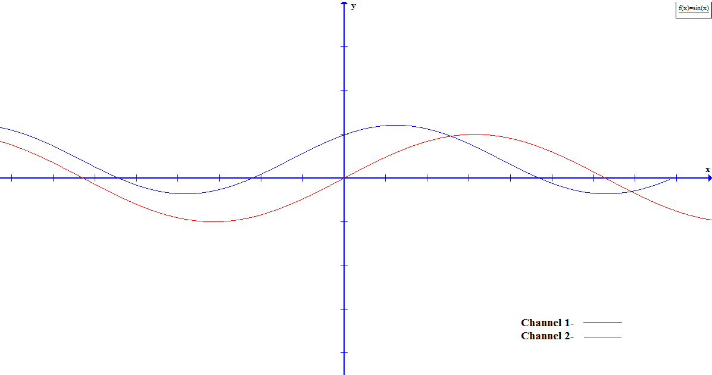

Here, channel 2 is leading and channel 1 is lagging.

(ii) Is there any discrepancy between the experiment and theoretical result on impedance and phase difference ? If so, why ?

**Answer:**

From experiment we get,

Tdelay = 0.16 ms

ƒ = 1Hz

Experimental Phase difference Ɵ = 360ƒTdelay = 57.6°

Theoretical phase difference Ɵ = tan­-1 (1/(2πƒCR)) = 58.38°

And,

Magnitude of impendence, |Z| = R* Vs / VR = 213.22

Theoretical magnitude of impendence, |Z| = sqrt(r2 + (1/(2πƒC))2) = 186.91

So, here we see a little discrepancy between the experiment and theoretical result on phase difference and as well as impedance difference.

We got some discrepancies because of ammeter, which is measuring very low current of circuit and also for the environment.

**7. Discussion:**

(i) For measuring current we have to use the exact value of ammeter Errors less than 10-3 will be ignored.

(ii) Measuring the resistance of resistors we have to remember that human hand can effect on the value of resistance. We have to avoid them.

(iii) When calculating data we should be very careful for approximate values.